Quarterly
Newsletter
Volume 3 – October 2021 SPNA Newsletter
Welcome  We are proud to publish the second issue of the SPNA Newsletter. It is a vehicle to provide vital information regarding best practices, advocacy, and current news from our local state and federal agencies. We feature a collection of reprinted materials that we hope you find informative. We will encourage original articles from the membership. We have listened to the ideas membership shared and continue to ask for feedback so that each issue can act as a significant and valuable source of communication for Early Childhood Professionals everywhere. |  | Inside This Issue  The Covid Issue  Page 2 “From the President’s Desk”  Page 3 – “Vaccine Update”  Page 4-5 Board Member of the Month  Page 5 Member of the Month  Page 6 State and Federal News  Pages 7-8 Local News  Page 9 Events  Page 11-12 Advertisements

Letter from the President
Brother Steve Davis

We tend to appreciate for the chance to be a part of something “Good”. We tend to be more respectful of opportunities to experience something “GREAT”. Through involvement with the SPNA (Supporting Professional Network Association), we are being Blessed to be a part of something that is truly “GREAT” because it touches so many people in a very special way.

As always, we welcome you to be a part of the 2021 SPNA Membership. We are appreciative & respectful of your choice to join, and in many cases rejoin, the SPNA (Supporting Professional Network Association). We believe that your membership can help to open professional doors & provide exceptional opportunities for personal growth & development. Your membership in the 2021 SPNA is expected to be a GREAT "Give-And-Take" Relationship.

We encourage you to take full advantage of the unique SPNA Membership benefits. If you do, then your membership dues & other contributions will be returned to you many, many, many times over. Here are some of the suggested benefits:
- Mentoring, support, monthly trainings & certificates to help satisfy DDCF mandated clock hours.
- Receive information on the best practices to enhance your childcare business operations.
- Receive updates on changes to DCFS licensing standards.
- Receive updates on union (SEIU) & so much more.
Yesterday was a “Good” day to build upon, in route to a ‘GREATER” today. Today is a “Good” day to think, speak & do something “GREAT”. Only today is a definite, so don’t let this day end without leaving your positive imprint on this day. Don’t be too proud or too busy to display a level of humility that can change the course of someone’s today.

Vaccination Update! Sept. 16, 2021
Northwestern University researchers assessing the response to COVID-19 for child care programs in Illinois have found the state’s efforts to bolster child care access to first responders while stabilizing the market were equitable and largely successful.
Their new report published Sept. 1, came after Illinois Gov. J.B. Pritzker’s move to make permanent a pandemic policy that lowered the cost of child care to $1 per month for families living in poverty.

On Monday, Pritzker announced that the state will provide three months of childcare assistance to unemployed parents who are seeking to reenter the work force as well as bonuses of up to $1,000 to those who work in a child care center or home child care in the state as part of an effort to stabilize the market.
“Governor Pritzker has been a leader in investing in the child care market and easing the financial burden of child care, especially for families facing economic hardship,” said Terry Sabol an assistant professor of human development and social policy in Northwestern University’s School of Education and Social Policy and a former elementary school teacher.
“Together, these policies reduce one major barrier to child care: cost,” Sabol said. “Moreover, the state is putting money directly into the hands of child care workers, who are notoriously underpaid. The median hourly wage of child care workers in Illinois is $12 an hour. This recent policy gives bonuses of up to $1,000 to those educators in child care centers who continue to provide a critical service during the ongoing pandemic.”
Article from “Northwestern Now” - 202

Meet the Board Member of the Quarter! Sabrina Limehouse
Sabrina Limehouse currently works with the state of Illinois and has been there since 2010 in the area of child protection. During her tenure with the child protection unit, she has worked in advance placement, family intact, and has been on 24-hour call to support families and children in crisis. Before her time with the department, she had over a decade of service working with private child care agencies. One of the private agencies she worked with was Centers for New Horizons, where she worked as an Infant Mental Health Worker. There, she worked to ensure that children with disabilities were provided the needed services to enable healthy growth and development. She remembers working with a child with a developmental delay and finding out through referral to specialists that the child had diabetes. As soon as the diabetes was treated, the child's delayed symptoms disappeared. She strongly feels early intervention diagnosis and treatment can guarantee a child can live up to their God-given potential.
Sabrina received her associate degree from Kennedy King College, her bachelor’s degree in Social Work from Northeastern University, and her master’s degree in Social Work from Aurora University. She is the mother of 2 children who have achieved their own greatness and a grandmother of a preteen granddaughter.
Sabrina always has had a desire to care for kids. She has been working with children since her early teens. She feels children can succeed if given ample resources and tools to empower their style of learning. "Every child can meet their potential greatness," she says. She feels her daughter is a prime example of success with the right resources. As Sabrina struggled to raise her, she worked hard to support her daughter's every endeavor. As a result, her daughter studied in Brazil, started her own internet resource business, and participated in national social media competitions. She says, "All you need is the passion for supporting the greatness in your children."
Sabrina has worked with SEIU to advocate for Family Child Care Workers. There she met a couple of the SPNA members and volunteered for the SPNA Back to School Rally. As a result, she was asked to join the board in 2015 and has been a board member since that time. Sabrina is presently the Co-Chair of SPNA's Board of Directors.
Sabrina's advice to SPNA membership is to embrace our children and look for ways to provide opportunities for them in your businesses. Push yourselves to participate in SPNA activities. 100% participation is what we must have to ensure SPNA's future growth! She feels that we have an opportunity to leave a legacy for our children, and Family Child Care professionals are in a perfect place to do just that!

Meet the Association Member of the Quarter

LaTonya Mitchell
LaTonya Mitchell is the founder and owner of Exceptional Little Leaders Academy. She has practiced providing child care services in her home since 2005. Her academy, located in the West Chatham community, received its LLC in 2013. She chose the world of early childhood education after her management work in the retail community. During her retail tenure, she had difficulty finding appropriate child care for her children and was also asked by other family and friends to provide child care. After her retail company closed, she fell in love with working with children and decided early childhood development was her calling. She has found over the years that she loves to be a part of the village of caregivers and an extended family member. She gets excited when she thinks about how she gets the opportunity to guide and mold the next generation.
Latonya has certification and associate degree in Early Childhood Education from Daily College. She has almost completed her bachelor's degree at National Louis University. She is a mother of three adult children and has 13 grandchildren. Her children live in Chicago, Florida, and one soon to be in to Korea. LaTonya enjoys giving back to her community. She serves on the West Chatham Park Advisory Council, West Chatham Improvement Association, and her Block Club Committee. LaTonya enjoys feeding our less fortunate brothers & sisters during the holiday seasons as well as creating and passing out care packages to them throughout the year.
LaTonya loves her work as a Family Child Care Home Professional! She especially enjoys introducing new concepts and watching children grasp the function of concepts and can participate in peer-to-peer learning. Some of her children return to visit her after graduating from high school. Some of her older students planned a reunion for her academy in her backyard during this summer. She has been told that she has built a community of learners and left lasting impressions that her past students cherish. Her parents also share the same type of enthusiasm for her work. They talk with her about their appreciation of her provision of a safe and loving place for learning.
LaTonya has been a member of SPNA for three years. She wants SPNA members to know that she is so proud to be a part of an organization of powerful women that looks out for one another. A group that encourages professionals to succeed. "Being a part of SPNA was one of the best decisions that she has made in her career - that "Black Girl Magic," she says with joy.
LaTonya wishes each professional success in running their business. “Sharing information with others and looking out for each member's health and wellbeing is what SPNA does” he says. I will continue to be a faithful member and help whenever I can to support other Family Day Care Home Professionals!

State News

Illinois Expanding Child Care Assistance, $300 Million In Relief for Providers,

Bonuses For Workers

By Kenzie Dillow, Sep 13, 2021- WSILTV

DHS will launch the Child Care Workforce Bonus program this month. Through the program, all staff at licensed and license-exempt childcare centers and homes will be eligible to receive up to a $1000 bonus, provided they meet all licensing and health and safety requirements. Childcare workers will receive the payment through their employer between October 2021 and March 2022.

Application information about the program will be available for employers via the Illinois Network of Child Care Resource & Referral Agencies (INCCRRA) in the coming weeks. Employers are required to pay staff 100% of the bonus amount awarded by the state.

The administration will also launch a final round of 2021 Child Care Restoration Grants and later this year will open applications for 2022 Stabilization Grants. The Child Care Restoration Grants administered through IDHS continue to offer childcare providers access to funds that can help counterbalance losses due to COVID-19 and take advanced steps to rebuild from the impacts of the pandemic
FEDERAL NEWS

Pentagon testing out covering in-home child care for servicemembers
Eric White@FEDERALNEWSCAS.com T June 29, 2021 11:49 am
The Defense Department will begin covering in-home child care costs for some military families under a new pilot program. DoD said the program will provide fee assistance for up to 60 hours per week of nannying and other in-home care. The amount of assistance will be determined by the service member’s total family income. The first year of the pilot will be limited to five high-demand regions, including the National Capital Region. Congress mandated the pilot program as part of the Fiscal Year 2021 National Defense Authorization Act
150 State and National Organizations Sent a Letter to Congress Calling for a Significant Investments and Policy in the Reconciliation Act – News from NFACC
The Senate Health, Education, Labor and Pensions Committee and House Education and Labor Committee pending reconciliation bill presents a crucial opportunity to improve child care in a sustained, systemic way. Your work on this will benefit the developmental, educational, and social-emotional progress of babies and young children, parents who need child care to be able to work and support their families, and the child care providers who have been underpaid for too long.
Excerpts from the Letter
On behalf of family child care educators across the country, we urge you to prioritize transformational investments and policy for child care in the pending reconciliation bill.
Family child care is the business and practice of early care and education in the early childhood educator’s home. Family child care offers the opportunity for one-on-one relationships and responsive and nurturing care in a small group, family-like setting to support positive outcomes for children. ... Parents can’t work to support their families without child care. Importantly, child care providers need to be paid a living wage and receive commensurate benefits to their public-school peers to remain health, and able to provide high-quality care and financially viable. Read more at https://nafcc.org/150-organizations-call-on-congress-to-support-family-child-care/

LOCAL NEWS

THE OBAMA PRESIDENTIAL CENTER
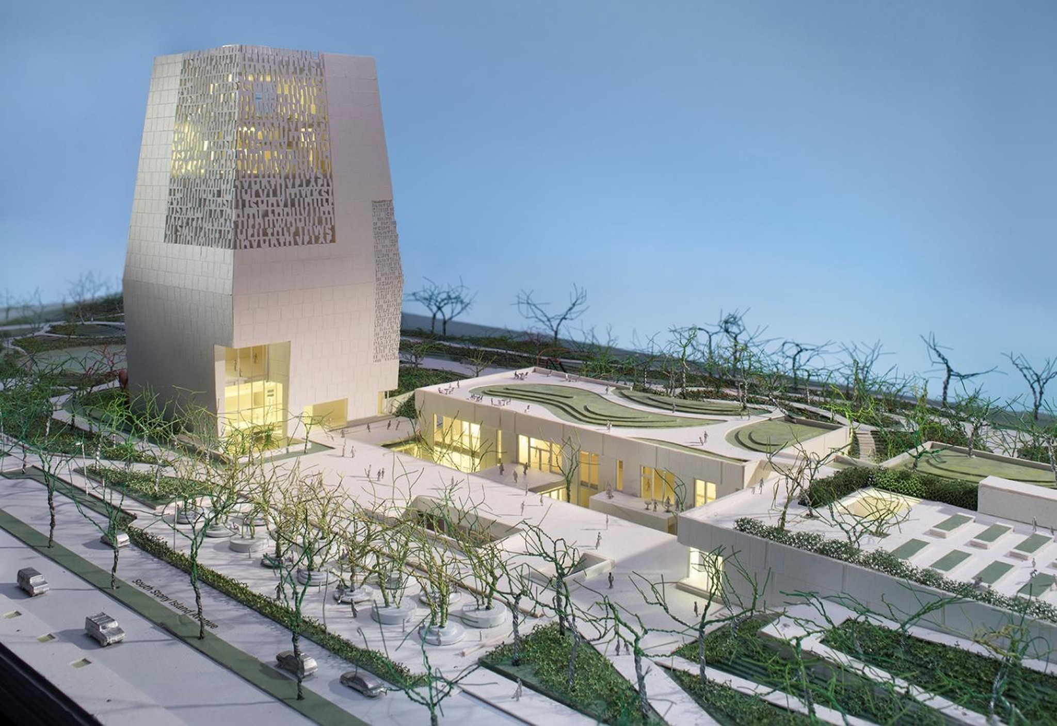
On Chicago’s South Side, the Obama Presidential Center will feature a world-class museum that chronicles President and Mrs. Obama’s leadership while calling hundreds of thousands of visitors to service. Designed by architects Todd Williams and Billie Tsien, it will be a place to reflect and grow, connect and create; to tap into your own sense of purpose and discover the change you want to make in the world. It will be a place to honor history while inspiring young people to write chapters of their own.
It will also provide our neighbors with a gathering space for celebrations, enriching its site in Jackson Park with new gardens for them to enjoy, an imaginative new playground for their children to explore, and scenic paths for early morning jogs or afternoon strolls.
And it will do all that while creating jobs, driving economic opportunity, and unlocking the potential that has always existed on the South Side. By tapping into the boundless talent of neighborhoods throughout Chicago, it will become a campus for the community, built in partnership with the community.
The Obama Presidential Center will connect the economy of the South Side of Chicago with the rest of the city, creating new jobs and opportunities. It will breathe new life into a park that has long been protected and loved, but underused. And it will uphold our commitment to this vibrant community.

It will also provide our neighbors with a gathering space for celebrations, enriching its site in Jackson Park with new gardens for them to enjoy, an imaginative new playground for their children to explore, and scenic paths for early morning jogs or afternoon strolls.
And it will do all that while creating jobs, driving economic opportunity, and unlocking the potential that has always existed on the South Side. By tapping into the boundless talent of neighborhoods throughout Chicago, it will become a campus for the community, built in partnership with the community.
The Obama Presidential Center will connect the economy of the South Side of Chicago with the rest of the city, creating new jobs and opportunities. It will breathe new life into a park that has long been protected and loved, but underused. And it will uphold our commitment to this vibrant community.
In 2008, our neighbors on the South Side of Chicago provided the base of support for a campaign that inspired the world and launched President and Mrs. Obama to the White House. The Obama Presidential Center is an opportunity to make history once again. Together, we can bring hope home.
A new branch of the Chicago Public Library will feature interactive digital media spaces and amenities for children, informational and vocational resources for adults, and a reading room for all to enjoy. This unique partnership is the first of its kind and will provide almost every South Side resident with access to a public library within walking distance. The branch will also have a garden on its roof. Similar to the garden that Mrs. Obama planted at the White House, it will be a place where young people and community members can get their hands dirty and learn about growing fruits and vegetables—and there will even be a few bee hives for honey. You can learn more about the Chicago Public Library branch and interactive studio.
The Children’s Play Area will feature a giant playground with innovative recreation equipment for children of all ages. The design of the play area celebrates the natural environment of Jackson Park, with lagoon and woodland-themed features to stir imaginations and encourage exploration. It will offer four seasons of play with plenty of seating and shade for parents and adults

This Photo by Unknown Author is licensed under CC BY-NC

National Conferences
Early Childhood Inclusion Institute 2021 Conference ATTEND ONLINE: October 25-28, 2021
ZERO to THREE Annual Conference 2021 ATTEND ONLINE: October 25-29, 2021
NAEYC Annual Virtual Conference
November 6-9, 2021

SPNA Leadership Conference
November 13 and 20, 2021

Conference Topics
Working with Children with Special Needs – Books, Support and Resources
Leadership For Family Child Care Home Professionals
SPNA Annual Meeting

TIPS FOR PROFESSIONALS
From NAEYC Family Child Care Home Interest Forum

Family Child Care Providers face a unique situation: we work where we live. It makes closing the door on our day challenging, especially if you love your job as much as many of us do. We give our all to the families we serve to make sure we provide the highest-quality care in a loving environment. But we must remember we are important, too. Practicing self-care can be as simple as changing the hours that you work.

Regular Physical Exercise
“I get up earlier than I need to so I have time to work out before I start my work day.”
-Sherrie Rose Mayle, Director

“I started doing yoga with a coworker after work. We worked in an infant toddler classroom, and at that time had a very challenging kiddo. That was over 12 years ago. Now I teach yoga, because it was so effective for me.”
-Amanda, Infant Specialist

Take time off
“I take off two weeks per year.”
-Tara, Director
“I also have a rule on Sundays that I don't open the computer or check email, so I have at least one full day for me and my family.”
- Sherrie, Director/Teacher

Connect with your spiritual side through meditation or prayer
“I get up, take care of myself, listen to a sermon, and pray.”
-Tamara, Owner/Provider

Further your education
“I always found taking training and reading ​in the field really reenergized me when I got in a rut, and it helped me do my job more easily and with greater confidence.”
- Hazel, Consultant

Develop resilience
“[I] have found that developing the [Center for the Study of Social Policy] five protective factors (parental resilience, social connections, knowledge of parenting and child development, concrete support in times of need, social and emotional competence of children)--resilience especially--is an effective and powerful tool to prevent burnout- Maureen, Owner/Director

Add something new

“I add new toys/centers, etc. or change up the room when I start feeling burnt out. It makes me excited again about my classroom.”
- Tara, Director

ADVERTISEMENTS
Level up your payroll process and reduce administrative burden, all while staying compliant. With custom reporting, employee self-service, and other features, get ready to improve accuracy and gain insight into powerful decision-making tools.

Matthew Mullally
Director of Sales
630.292.2071
mmullally@paylocity.com
Employees rely on their paychecks, so you have to get your payroll right. Use our software to simplify payroll, automate processes, and stay tax compliant, all in one spot. Pull expense reimbursements into paychecks and run custom reports to get the data you need.

ADVERTISEMENTS

Soul, Mind, Body, & Spirit
YOUR RELAXATION SANCTUARY IN THE CITY
2140 W. 95 TH ST. CHICAGO IL
Energy Healing Massage Stress Relief Massage
Therapeutic Massage
Aromatherapy Massage Hot Stone Massage
Foot Reflexology Therapy Thai Hand Reflexology
https://www.vagaro.com/us04/thereikiklubhouse
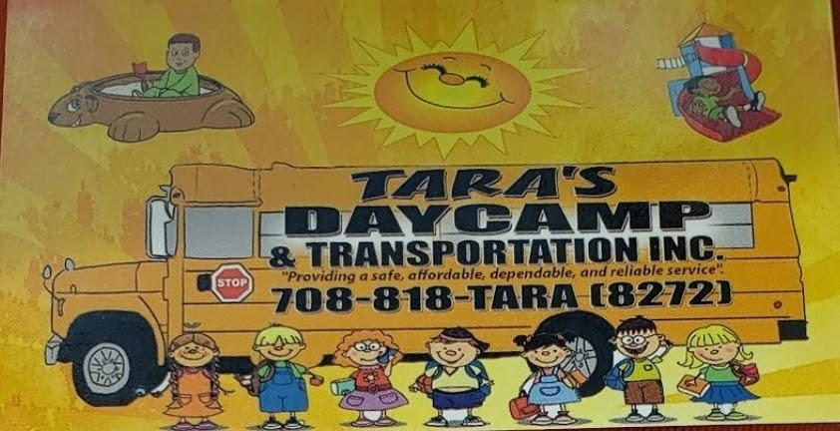

Thank you,
For your continual service to children and families!

